**­STAT 477/STAT 577**

**HW 3**

**Neha Maddali**

1. The number 13

a. Summary Table



Bar Graph

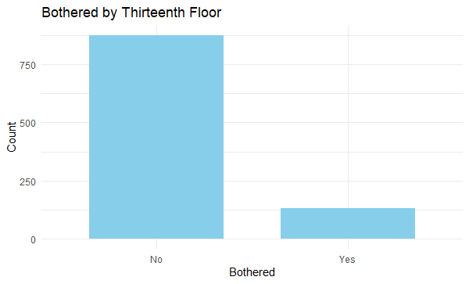

b. Confidence Interval = [0.1094222, 0.1510152]

c. Interpretation of Confidence Interval: The 95% confidence interval for the population proportion bothered by staying on the 13th floor, based on the normal approximation method, is [0.109, 0.151]. This means that we are 95% confident that the true proportion of individuals bothered by the 13th floor lies within this interval, suggesting a relatively narrow range for the estimated population proportion.Top of Form

d. Confidence Interval = [0.1108208, 0.1524299]

Compare to interval from part b: The 95% confidence interval for the population proportion bothered by staying on the 13th floor calculated using Wilson’s score method is [0.1108, 0.1524]. When compared to the interval obtained in part b, the intervals are very close, indicating that both methods yield similar estimates for the population proportion with a 95% level of confidence.

e. sample size = 1691 (refer to R code, using normal approximation method)

2. Global warming

a. population proportion of interest = p refers to the proportion of all adults aged 18 or older in the US who believe that global warming is more a result of human actions than natural causes. P represents the true, underlying proportion of individuals who hold this belief in the entire adult population.

b. sample proportion = p̂ = 662/1019 = 0.64966

c. Confidence Interval = [0.6198521, 0.6783369]

d. Interpretation of Confidence Interval: We are 95% confident that the true proportion of individuals who hold this belief that global warming is more a result of human actions than natural causes lie within this interval, providing a range for the estimated population proportion.

e. sample size = 1537 (refer to R code, using normal approximation method)

3. Coverage Rate

a. Any different from 95%? If so, which one(s)?

When p = 0.05 and n=25, the coverage rate is notably lower at 72.133%

When p = 0.5 and n=25, the coverage rate is higher at 95.695%

b. Any different from 95%? If so, which one(s)?

When p = 0.05 and n=25, the coverage rate is notably higher at 96.664%

When p = 0.25 and n=25, the coverage rate is lower at 93.853%

When p = 0.5 and n=25, the coverage rate is higher at 95.661%

c. Any new information by adding p = 0.75 and p = 0.95 to simulation? Explain.

Yes, including values of p=0.75 and p=0.95 would provide valuable information. Including these values can represent scenarios where success is more likely, and we could gain insights on how well the confidence interval methods perform across a broader spectrum of probabilities. Including higher values of p in the simulation allow us to assess the methods’ performance under different conditions especially when the probability of success is closer to 1.

4. Zodiac

a. Summary Table

Bar Graph

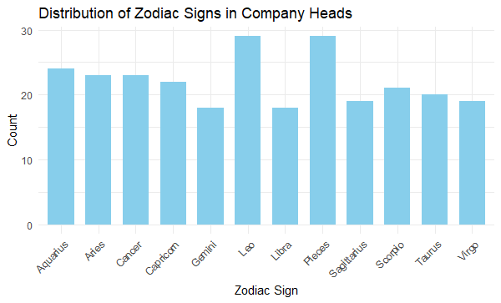

b. Null Hypothesis H0: the distribution of zodiac signs is equal (p1 = p2 = … p12)

Alternative Hypothesis Ha: the distribution of zodiac signs is not equal (p1 ≠ p2 ≠ … p12)

c. Expected Value = 22.08333

d. Contribution from Scorpio = 0.05314465

e. Test Statistic = 7.196226

f. Degrees of Freedom = 11

g. p-value = 0.7829773

h. Conclusion = There is not enough evidence to suggest a significant association between zodiac signs and the likelihood of being a head of the largest 400 companies.